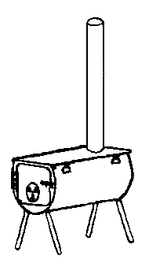
Cylinder Stoves
4150 East 13000 North
Chester Utah 84623
800-586-3829

Window Kit Installation
- Cut 3/8” thick plywood to fit the open window. It will replace the screen, so you can probably cut the same size as the screen or just a little smaller.

- Cut hole in plywood approximately 14” square. You want the center of the hole to be 4’6”

to 5’ from the floor. If stove has 22” legs, raise center of hole to 5’6” to 6’ from the floor.

If you are using and oven , raise center of hole to 10” from top of ply wood

- Using screws provided, attach bottom half of sheet metal wall plate to plywood. Top half of wall plate will be installed after pipe is installed. (if you want to paint or stain the plywood, do it before attaching the metal plate).
- Install plywood in window track where screen was.
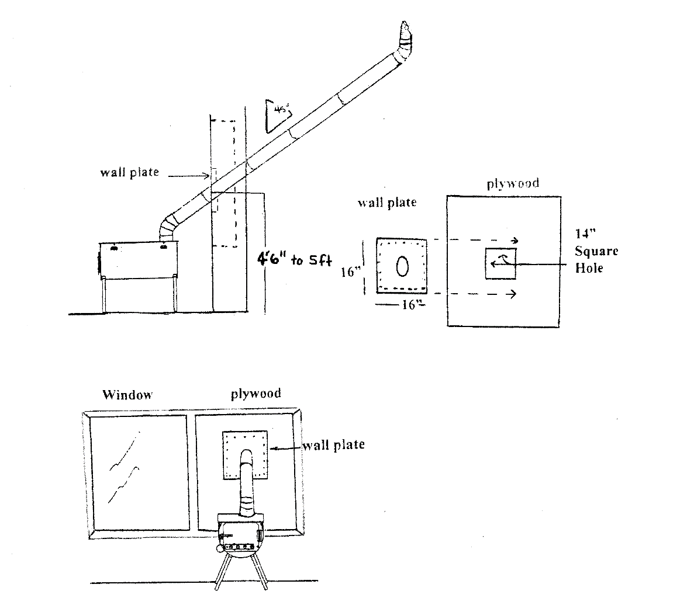
- Set up stove approx. 2ft. from wall install 5” adjustable elbow on stove, assemble pipe and insert through opening in plywood. Usually the #2 piece of pipe will be the one resting on the bottom half of the sheet metal wall plate. Install 6” elbow on top of pipe and point it straight up to prevent wind from blowing in the end of pipe. Then install spark arrestor or rain cap on top of elbow on stove pipe.

--- ---

