CYLINDER STOVES
Pellet Burner
Parts List

A - Body
B - Mounting Flange
C - Cover Plate
D - Shuttle
E - Control Rod Bolt
F - Heat Shield
H - Hopper
I – Hopper Cap
J - Lighting Hole

1-800-586-3829

Pellet Burner Installation Instructions

For stoves without factory installed pellet burner hole see “Do it yourself” instructions printed on template sticker.
Install pellet burner body (A) by tilting it up at an angle and inserting pins on mounting flange (B) in holes above 4x4 opening on stove. Swing body down into place making sure pellet burner body fits firmly into the hole. Stove should be level and pellet burner will slope slightly downhill into the stove. This is necessary to keep lighting fluid from dripping out back of pellet burner.
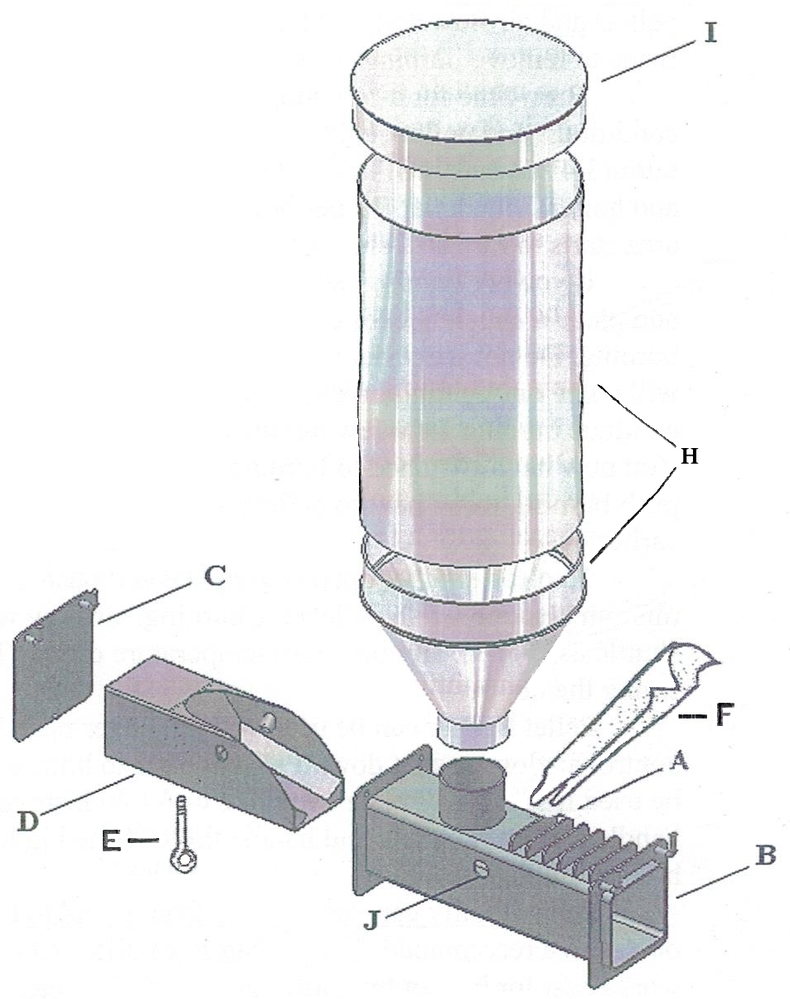
Remove cover plate (C) on back of pellet burner body, make sure shuttle (D) slides in and out smoothly. Note the ¼” hole with nut on bottom of shuttle, this is where the control rod bolt (E) connects to shuttle through air intake slot on bottom of body. Reinstall shuttle and cover plate, then install control rod bolt.
Shuttle can now be moved back
and forth by pulling or pushing on
control rod bolt, this will control the
amount of pellets that can slide down
into the burn chamber. Pushing all
the way back will be wide open,
pulling all the way forward will be
closed.
Install heat shield (F) between
stove and pellet burner hopper as per
diagram to keep pellets from getting
hot. Some pellets get sticky when hot
and don’t flow well.

Wire cleaning rod is used to break
up the buildup of ash in the shuttle.
Sweep side to side in burn chamber
of shuttle, from rear of pellet burner
while it is burning. This will disturb
the ash and will blow it into the stove.

