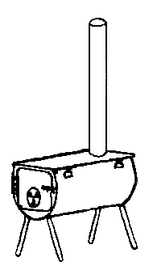
Cylinder Stoves
4150 East 13000 North
Chester Utah 84623
800-586-3829

Internal Tent Frame Instructions

Unpack frame poles and separate pieces into rafters, ridge, and legs. Each pole is marked what it is. All leg poles will be one piece, all rafters will be 2 pieces (jointed). Ridge poles will either be one piece or two pieces (jointed) depending upon tent size and number of rafters.
Unpack angle fittings and separate into corners (three way fittings) and middles (4 way fittings). If some angles have a ”R” welded on them they must be used on the tent Ridge. They will be different than the other angles. If you do not have angles marked “R” then all angles are the same and can be used for both the ridge and eave of tent.
Place 4 corners angle fittings at the approximate corners of the tent. Put angles that have a bolt welded on top of them at the ends of the Ridge pole. A 4 way angle is used at the ends so that you can extend your frame for a rain fly or porch. The bolts will go through the grommets at the ends of the ridge of your tent. Lay out your ridge poles into three lines, one ridge and two eaves (all will be marked ‘ridge’). Put middle angle fittings on to attach ridge poles together. Assemble Rafter pieces and install them between Ridge pole and eave poles. You now should have the shape of the roof assembled on the ground.
Unfold tent and put it on the frame. Make sure to fit grommets at end of ridge over the bolts on the frame this keeps the tent stretched and aligned properly. Lift one side of frame and insert legs, then do the same on the other side. Now fit tent over completed frame and stake down the bottom of tent using stakes with hooks on them. Staking doors is optional.
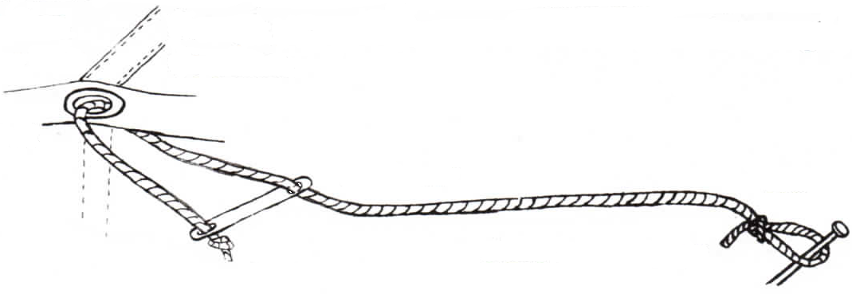
Take ropes and tie a stake loop on one end. Thread other end of rope through metal tensioner, then through grommets on eave of tent, then back through other hole on tensioner then tie knot.

tent eave grommet

tensioner stake

knot stake loop in rope

Stake corner ropes at a 45 degree angle from end of tent adjust tension until tent is even and tight. Always stake and rope tent if tent might get wet or if there is any chance of wind.
After your new tent is set up you need to soak the outside and inside of tent with garden hose, to seal up needle holes in seams from water leakage. Don’t put tent away wet! Dry completely before you pack tent away. The frame is built approximately 2% smaller than the tent to allow for some shrinkage.

