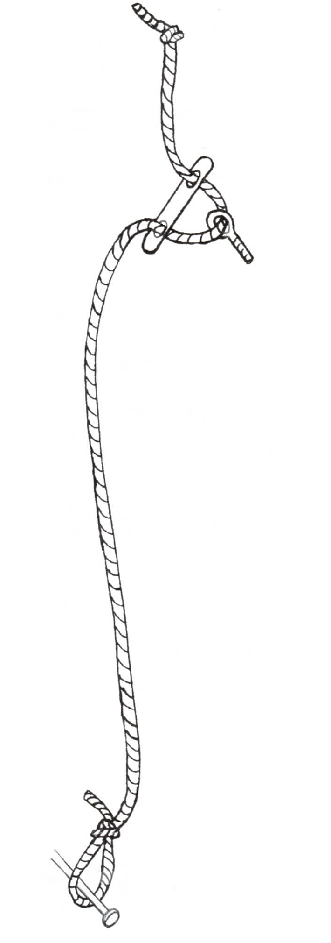
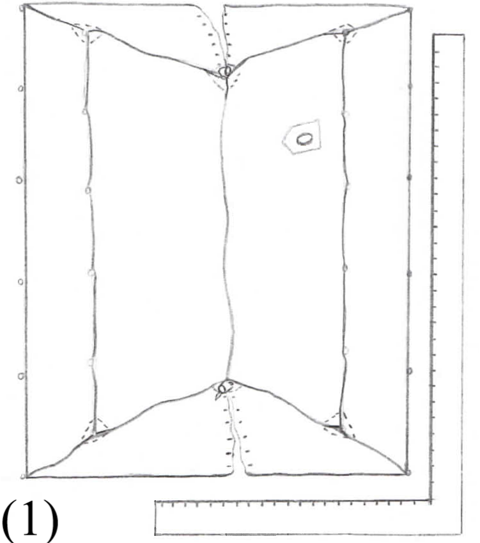
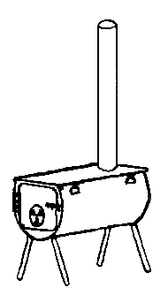
CYLINDER STOVES
4150 East 13000 North
Chester, UT 84623
800-586-3829 A-FRAME INSTRUCTIONS

1. Unpack tent and find rope and metal tensioners. Thread rope through one end of tensioner, then through eyebolt, then back through other hole on tensioner, then tie knot. Tie stake loop on other end of rope.
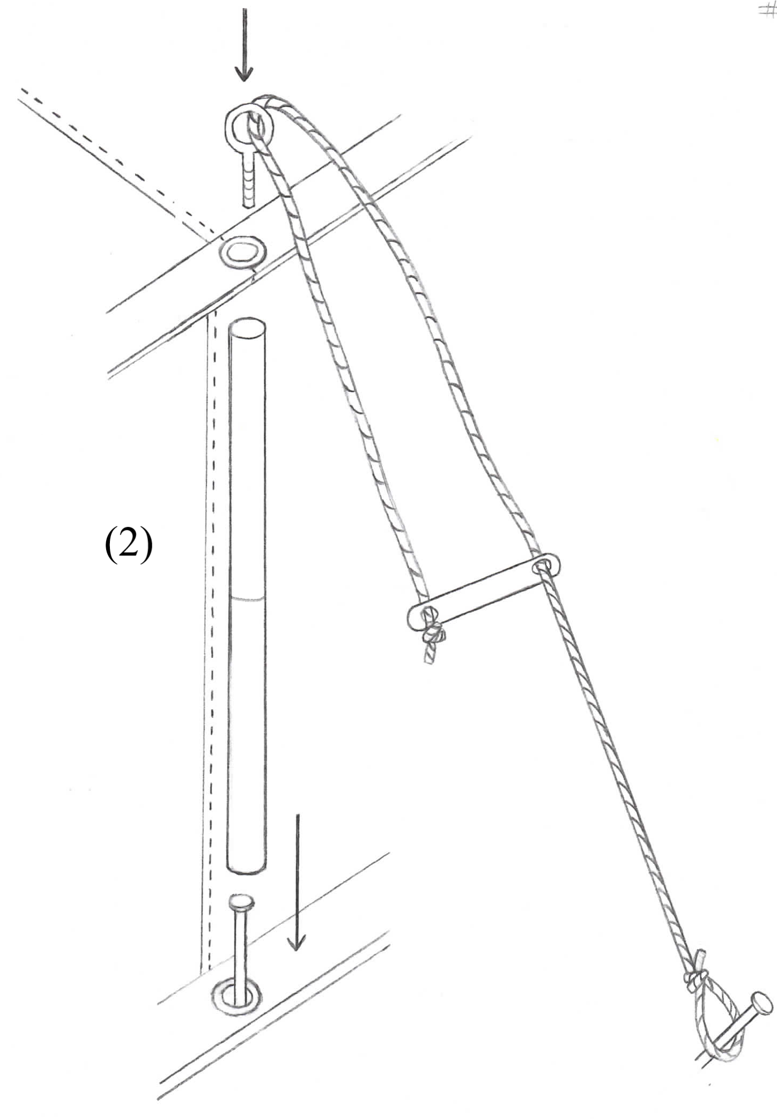
eye bolt stake

tensioner
knot stake loop in rope
2. Stake out corners of tent. Pound log nail stakes through grommets on bottom of tent, leave approx. 2-3” above ground. Try to get tent as square as possible. (1) Make sure buckle at bottom of door is fastened. This keeps door from getting stretched too tight for zipper to work freely. Stake down rest of tent keeping walls straight. Assemble 2 pc. sidewall poles (1 piece 23 in with swaged end, 1 piece 39 7/8 in. plain end)

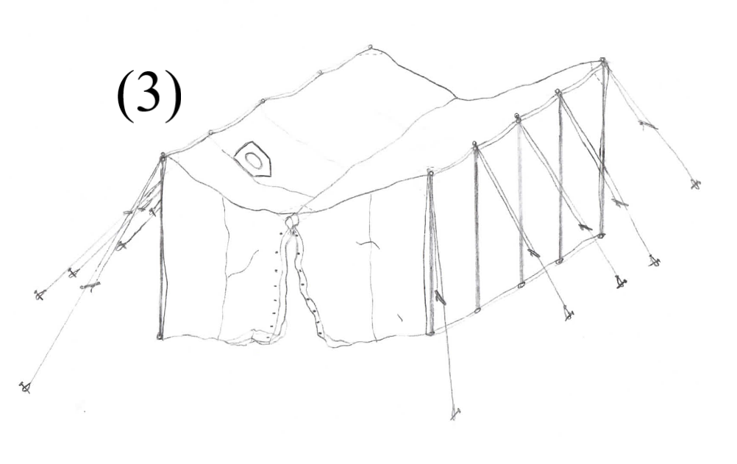
3. Install side wall poles by placing sidewall pole over top of stake and set it on top of grommet. This holds bottom of tent down and keeps sidewall pole from moving. If you are using different stakes, let side wall poles stand on the ground. Insert eyebolt thru eve grommet and into top of sidewall pole. (2)Stake out ropes and adjust tensioners so that rope holds sidewall poles upright - don’t tighten yet. Do corners first, and stake corner ropes out at a 45 degree angle from end of tent. Once side wall poles are up, this will allow you enough room to get ridge pole through tent without having to crawl (3).

4. Assemble legs and place two in front of tent and two in back. Leg pieces are marked blue, green, and brown and must be assembled in sequence with blue at top, green in middle and brown on bottom. Assemble ridge pole outside of tent.
Assemble ridge pole cable truss as shown on back. Take ridge pole through
door and stick it through ridge pole opening at back of tent, then bring it back
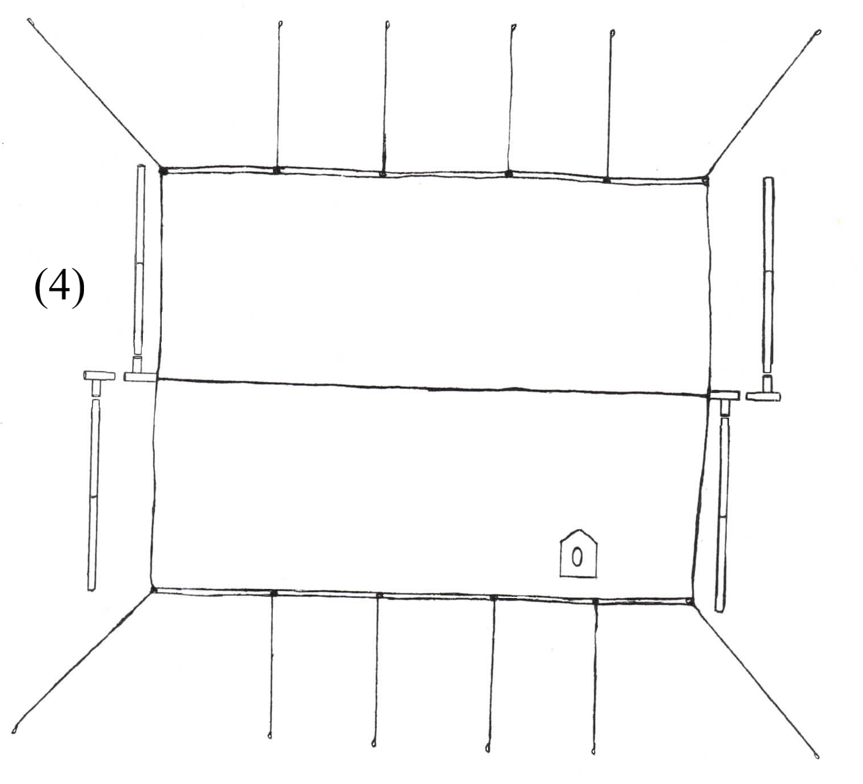
through front ridge opening, put tent ridge grommet on bolt at end of ridge pole.

5. Insert adjustable leg fitting (T shaped pieces) into ends of ridge pole. Turn this adjustable leg fitting to be the right side leg. (4)This will make the cable truss hang evenly in center of legs. Legs go on the outside of tent. Insert legs into welded leg fitting on ridge pole and adjustable leg fitting, lift ridge pole by bringing legs closer together. Lift both ends evenly.

6. Make sure legs have a sufficient bite in the ground to hold them in place. Also make sure legs are even vertically with the end wall of tent, or slightly closer at the bottom. By moving legs closer at the bottom it puts tension on frame and keeps joints tight (5).
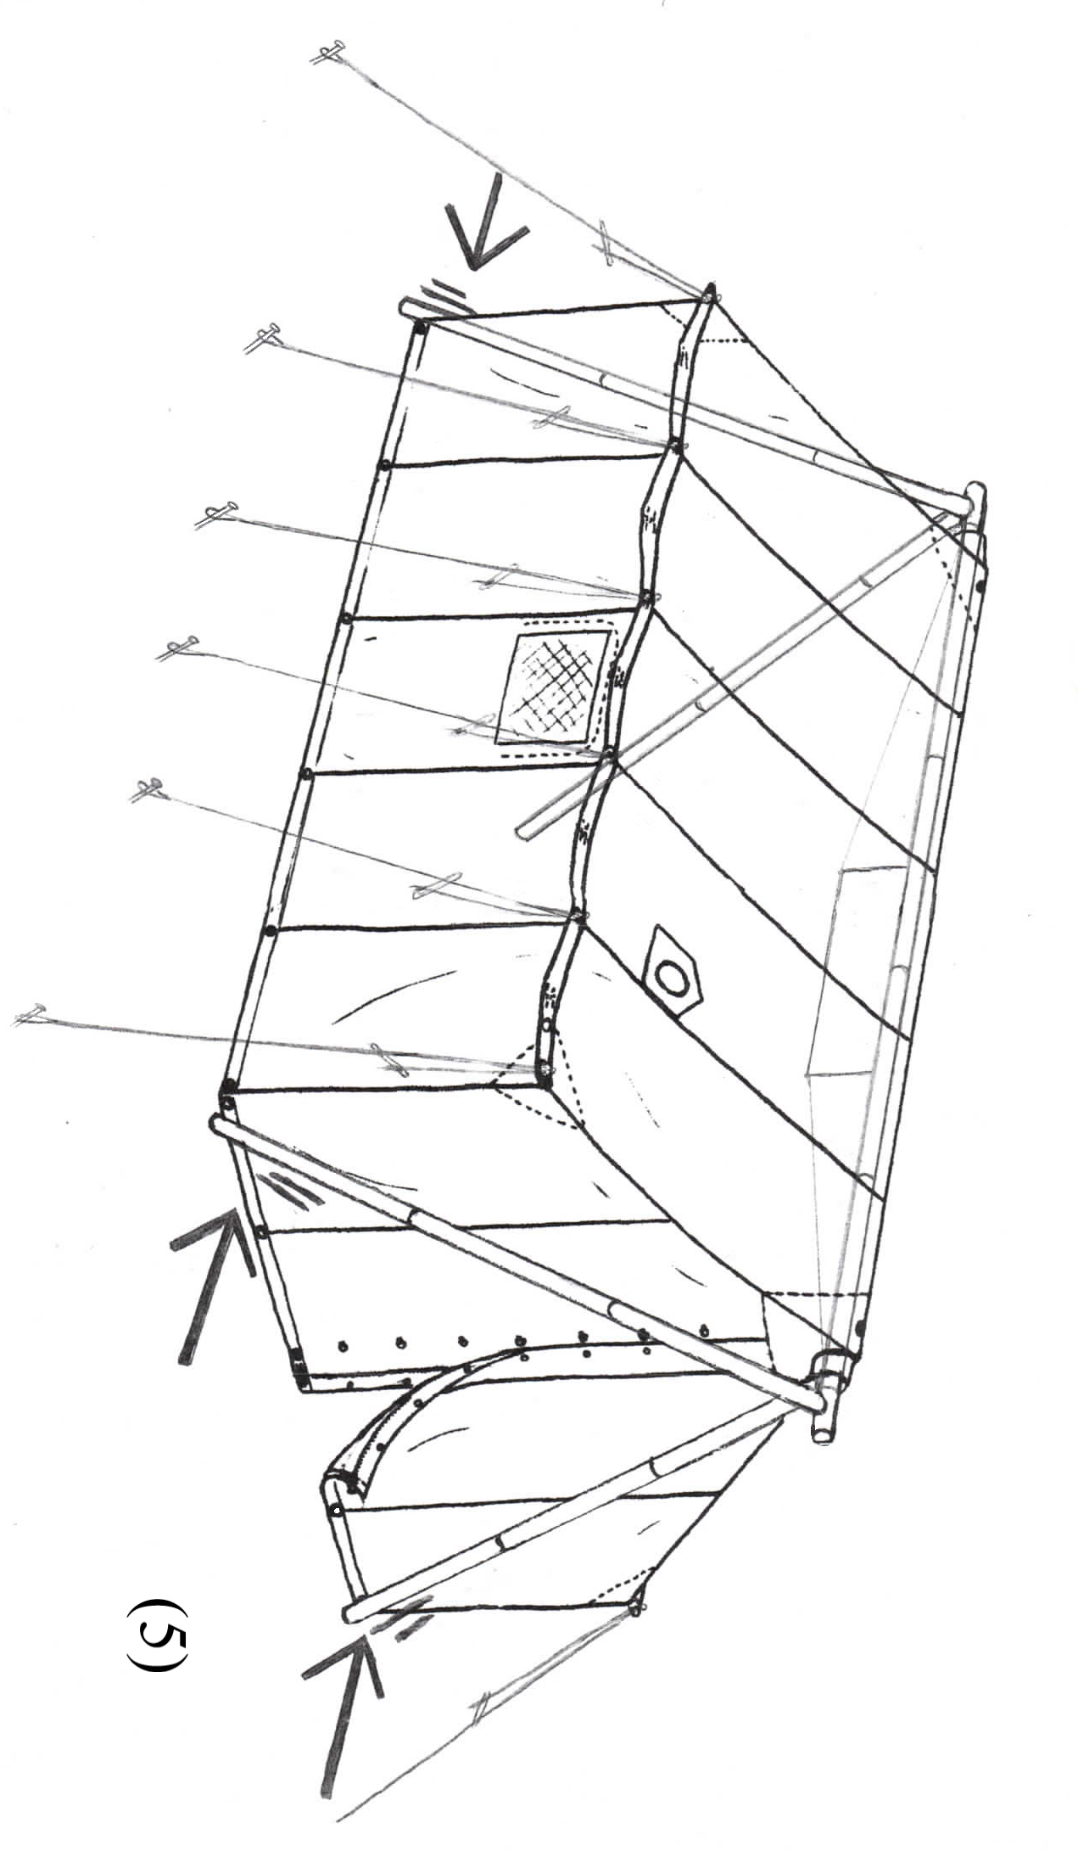
7. When ridge pole is at proper height, make sure it is centered in peak of tent by moving either right or left leg accordingly. Go around tent and tighten ropes as needed. You may have to move corner ropes to get corners tight. For extra stability, it is a good idea to have a rope staked out from both ends of the ridge, this eliminates wrinkles in ridge and keeps ridge tight. These ropes should be 15 - 20 ft. long so they can be staked out far enough to avoid doorway. Alternative: use a short rope and just tie tent ridge
to end of frame to keep it tight. This is easiest to do before ridge is raised all the way.
You may have to tighten ropes periodically in windy conditions

8. Take tent and frame down in reverse of instructions. When packing frame back in bag, you will want to put smaller poles inside of larger poles to save space. Put ropes, cable, and stakes in tent bag after tent is folded and packed.

